Guided Capstone Project Report

The current ticket price that Big Mountain Resort charge is of $81.00. This study indicates that there are 8 factors that affect the price of resorts such as Big Mountain Resort. These factors are vertical drop, area covered by snow making machines, total chairs, fast four person chairs (fast quads), runs, longest run, trams, and skiable terrain.

The model shows that, without making any more improvements, market could allow the price of the ticket to go up to $95.87, a $14.87 difference from the actual price. The mean absolute error is $10.39, since the mean absolute error is a little over $4 below the difference of the suggested price and the actual price, there is room for an increase in the ticket prices.

The following picture shows that the weekend ticket prices for adults in Big Mountain Resort seems to be fair and with room for increase:

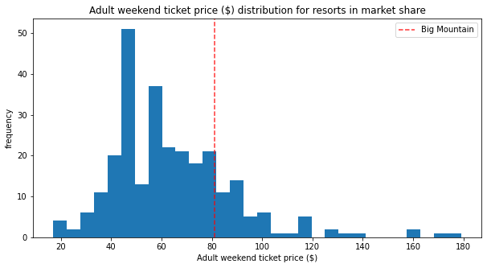

However, if considering the prices of resorts located only in Montana, Big Mountain Resort should be aware that they charge one of the highest prices.

Those are the 2 scenarios that the study identifies as the best possible options. For a more detailed study and report more data is needed.

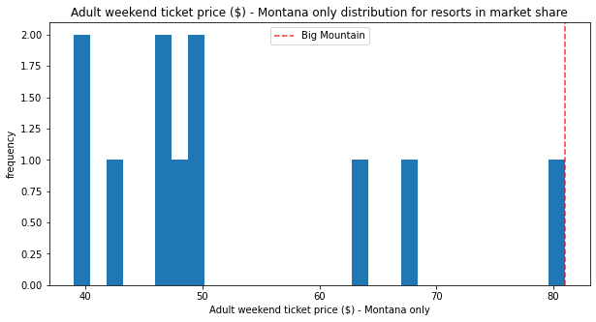

The following picture depicts the importance each factor has on the pricing of the tickets:

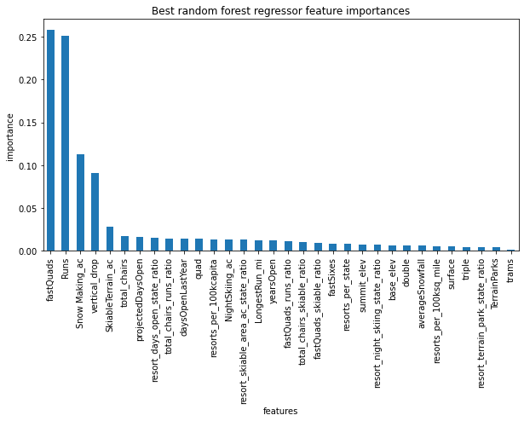

To do a fair ticket price increase, the study considered 3 changes. These changes were to increase the number of runs by 1, increase the vertical drop by 150 feet, and install an additional chair lift. These changes would support a $1.99 ticket price increase.

To increase the maintenance savings, the study considered closing some of the existing runs. By closing 1, 2, or 3 runs, the ticket price would need to decrease drastically. However, by decreasing the amount of runs from 3 to 5 would keep the ticket price decrease at the same level as the picture shows.

